Investigating why large ships float and keys sink? Experiment 4: Surface Area & Buoyancy
Creating a Boat that will Float
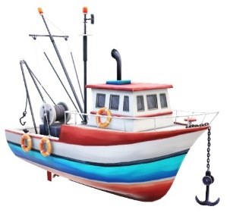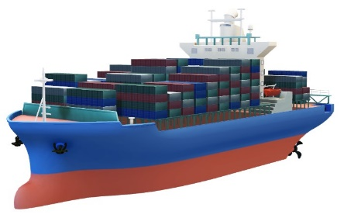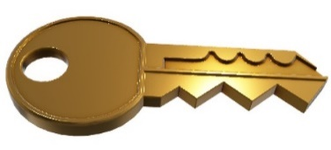
Objective: To determine if the surface area and buoyancy of an object will cause an object to sink or float

Question: What type of surface area and buoyancy is required to float objects

Materials you will need:
- Worksheet and pen / pencil for recording your results.
- A Large basin or bowl of Water – hall full.
- Plasticine to make a miniature bowl with a round bottom and a bowl with a flat shaped bottom (alternatively us a plastic cup and plate)
- Stones
- Plasticine
- Balloon

Instructions:
Stage 1: A bowl shaped ship and cargo
- Create a bowl shape out of the plasticine that represents a cargo ship. Place it into the large basin of water. Observe what happens – did it float?
- Create a pile of small rolled up pieces of plasticine to put into the bowl. These can represent your cargo containers. Add the small pieces of plasticine into the ship one at a time.
- Observe what happens to the ship and the level of water in the basin as you add more cargo. What happens if you had to many cargo containers? How many cargo containers did it take to sink your ship?

Stage 2: Redesign your ship
- Redesign the shape of your boat making the surface area wider surface area and a deeper bottom.
- Predict how many plasticine balls it will take to sink the new design using a boat with a greater surface area.

Part 3: Add buoyancy devise to your ship
- Add a buoyancy feature to your ship
If you were to attach a tiny balloon with air in it, would this help the ship stay afloat? Where would you place the balloon to help the ships bouyancy?
- How much cargo will the ship take now before it sinks?
Worksheet 4 / Results: Surface Area & Buoyancy
Creating a Boat that will Float

Objective: To determine if the surface area and buoyancy of an object will cause an object to sink or float

Question: What type of surface area and buoyancy is required to float objects

Complete stages 1 & 2 experimenting with the different shaped plasticine boats and cargo.

Explain what happened when you floated the plasticine ship (shaped like a bowl) in the basin of water compared to the plasticine ship that has a deeper bottom and wider surface area at the top. What happened when you gradually added cargo to it. How many cargo containers did it take to sink each of the ship?

Record what happened to the ships

Explain what happened when you placed the plasticine ships into the basin of water. Did they sink or float?____________________________________________
____________________________________________________________

What was the level of the water like with each of the ships? ____________________________________________________________
____________________________________________________________

Explain what happens to the ships, when you added your cargo. What happens to the level of the water _______________________________________________
___________________________________________________________

Explain how much cargo it took to sink each ship?. ________________________
___________________________________________________________
________________________________________________________________________________________________________________________

By changing the shape of the boat were you able to increase the amount of cargo on the boat. Explain your outcome? __________________________________
___________________________________________________________
___________________________________________________________
___________________________________________________________
___________________________________________________________

Stage 3: Other features of a ship to create buoyancy

Try creating a ship using plasticine and small balloons to help the ships buoyancy.
Repeat the experiment above and record what happened.
Explain the outcome of what happened and explain why.

Record what happened

Explain where you placed the balloons to help the ships buoyancy. ___________________________________________________________
___________________________________________________________
___________________________________________________________
___________________________________________________________

Explain the buoyancy device helped keep the ship afloat when you added your cargo to the ship.
___________________________________________________________
___________________________________________________________
___________________________________________________________
___________________________________________________________
___________________________________________________________

After making the different types of ships that were built from plasticine, provide a conclusion explaining how the surface area and buoyancy of an object will help it float

Conclusion of Experiment 4

___________________________________________________________
___________________________________________________________
___________________________________________________________
___________________________________________________________
___________________________________________________________
___________________________________________________________
___________________________________________________________
____________________________________________________________

